Credit Card Customer Churn Prediction

Business Problem
The banking industry has become highly competitive, especially in the credit card segment. Banks invest significant resources to acquire new customers through marketing campaigns, promotions, and partnerships. However, retaining existing customers is equally important, as losing customers results in long-term revenue loss.
This study aims to identify the key factors that lead customers to cancel their credit cards and switch to another provider. Understanding these factors can help banks take proactive steps to improve customer retention and maintain a stable revenue stream.

Background and History
A customer churn (or customer attrition) is the rate of customers that stop doing business with their current business entity. This group of customers either stop or cancel their credit cards for various reasons, such as improved financial situation, dissatisfaction of service, lack of value, or due to competitive alternatives offered by other banks. Usually, customers stick to one or few credit cards for many years or perhaps for the rest of their life if issuer provides good service. This is the main reason why clients are hesitant to switch to a new issuer, making it difficult for banks to acquire new customers. Obviously, losing them would hurt entity’s revenue. Today, with the advance in technology, Machine Learning (ML) became one of primary prediction tools to forecast customer churn rate by learning and analyzing historical customer data like usage behavior, and demographics to identify patterns of customers that are likely to cancel their cards.

Data Explanation
For this study the dataset Bank Churners was acquired from Kaggle. This dataset has 10,127 rows and 23 columns. Each column represents more or less important variable. Each column feature represents transaction or demographic data of a customer such as age, gender, marital status, credit limit, transaction amount, existing or churn customer, education level, income and other similar data. The last two Naive Bayes columns were removed to avoid data leakage. This dataset is clean and has no missing value.

Methods
In this study, I used Python programming language and several libraries like pandas, numpy, matplotlib, seaborn and others to process and visualize the data. I cleaned the data by removing the last two Naive Bayes columns to avoid the risk of data leakage for training Machine Learning. I explored the data by visualizing and displaying all the means, medians, minimum and maximum values and other quantitative data such as standard deviation to get insight of the data. I converted target variable which is Attrition Flag into zero for Existing Customer and one for Attrited Customer, this way the data can only have binary outcomes and split into two different categorical groups. I displayed the churn distribution of the data in column chart to quickly visualize and get insight into data. This data is highly imbalanced representing 8,500 (or 84%) existing customers and 1,627 (or 16%) churned customers. Also, Age vs Churn box plot chart visualized the age of the existing and churned customers. Both groups have almost identical median age with churned customers very little, almost unnoticeably above. The credit limit vs churn chart was used to identify visually if credit limit amount has any decisive impact for customers to cancel their cards. It appears both medians are very similar and almost identical with churn customers group having marginally lower. The use of Transactions vs Churn graph reveals good insight and perhaps decisive reason as a reason why churn customers cancel their cards. The median for the churned customers is substantially lower than for existing ones, clearly showing strong impact on consumer spending activity. Gender vs Churn chart didn’t reveal any clue. The male and female group being almost similar with slightly higher for female existing and churned group. The gender variable doesn’t seem to have much impact on churn behavior.

Additionally, feature engineering was used where I categorized word variables by encoding them into numerical values so my Machine Learning could process and learn the data. In the modeling step, the data was split into X and Y variables and Logistic Regression, Random Forest models were used. The Logistic Regression model was chosen for this study because we are dealing with binary data, where we need to sort the data into two outcomes, existing and churned customers. The Random Forest model was used because it can capture complex relationships in the data and generally performs well on classification problems. Then Model Evaluation was performed and showed promising results. Logistic Regression Accuracy scored 0.86, Random Forest Accuracy 0.9555, and ROC-AUC (RF) accomplished 0.987. The Confusion Matrix on Random Forest was used to see how the model accurately identifies each client. The model correctly identifies 2,515 true existing customers, and 389 true churned customers. With 107 false existing customers and 28 false churned customers. This is a relatively good outcome, and we can conclude that the model’s performance is accurate. Lastly, the column chart was used to visualize Feature Importance of top 10 most important features. Clearly the Total_Trans_Amt (Total Transactions Amount) with substantially above 0.175 score is the most important feature, then Total_Trans_Ct (Total Transactions Count) with approximately 0.170 score is the second most important feature, and both Total_Ct_Chng_Q4_Q1 (Total Count Change from first to fourth quarter) and Total_Revolving _Bal (Total Revolving Balance) having approximately 0.100 score each. The remaining six variables were less important, having way below 0.075 score.

Analysis
The analysis focuses on the most influential features identified during the modeling process.

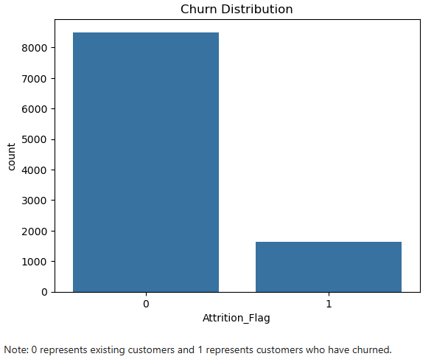
Figure 1: Churn Distribution of Customers

The above Churn Distribution chart displays very imbalanced distribution. The left column displays existing customers staying with their current bank issuer representing approximately 83.9%, while the right column shows churn customers approximately 16.1% who canceled their credit cards and either don’t need anymore to use card or left to another issuer bank.
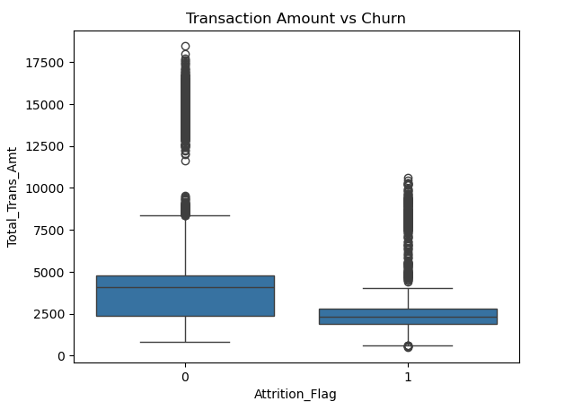
Figure 2: Transaction Amount vs Churn

From the Transaction Amount vs Churn chart, it is clearly visible that the median transaction amount for churn customers is substantially lower than for existing customers indicating that the Transaction Amount feature is very important feature and most likely have substantial impact on churn client’s cancelation behavior. For existing customers, the whiskers range much wider with the top threshold at approximately $8,750 total transaction amount spent for the past twelve months. The median for existing card clients at approximately $4,900, meaning existing customers are spending much bigger total annual amounts on their shopping. Banks should pay close attention to this amount because below this amount, the risk of existing customers turning into churn customers is rising. On the other hand, the median number of churn customers annual total transactions amounts is much smaller and stands at approximately $2,500. The churn customers noticeably spent much lower amounts on their purchases. The upper threshold for churn customers range of the top whiskers end approximately stands at a little over $4,900. This appears to be a threshold level where the risk of churn increases.

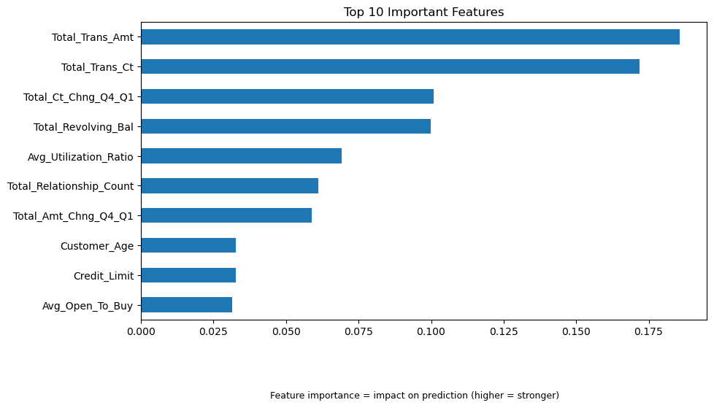
Figure 3: Top 10 Important Features

The Top 10 Important Features chart ranks the most influential features in predicting customer churn from highest to lowest importance. The two most significant features are Total_Trans_Amt (Total Transaction Amount), with an importance score above 0.175, and Total_Trans_Ct (Total Transaction Count), with a score of approximately 0.170. These results indicate that customer transaction activity plays a major role in churn behavior. The remaining features have lower importance scores, generally at or below 0.100, suggesting a smaller contribution to the model’s predictions.
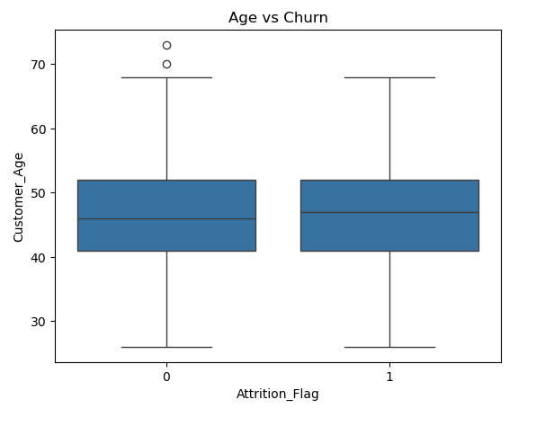
Figure 4: Age vs Churn

The Age vs Churn chart shows median of ages for each group. There is not much difference between the two medians. For existing customers, the age median approximately 46 years old and for churn customers, the age is a little bit above 46 years old. Thus, the feature does not appear to have a significant impact on churn behavior. Both box plots for each group are almost identical.

Conclusion
To summarize the findings of this study, several features were identified as important in predicting customer churn. Among them, Total Transaction Amount and Total Transaction Count were the most influential factors, indicating that customer activity and engagement play a key role in churn behavior. However, other features also contribute to the model, although their impact is less significant.
The models used in this study include Logistic Regression and Random Forest. Logistic Regression achieved an accuracy of approximately 86%, while Random Forest performed better with an accuracy of about 95.5% and a ROC-AUC score of 0.987. This indicates that the Random Forest model is more effective in distinguishing between churned and existing customers.
The confusion matrix shows that the model correctly classified the majority of customers, with relatively few misclassifications. This suggests that the model performs well and can be useful in identifying customers who are at risk of leaving.
Overall, the results show that customer transaction behavior is a strong indicator of churn, while demographic features such as age and gender have less impact.

Assumptions
It was assumed that the data represents real customer behavior and features are accurate.

Limitations
The dataset might not represent all banks or many banks. This dataset might present customer data from one or few banks, which might not be enough to cover wide range of customers. The dataset might only represent customers of US banks, but not international banks. Each country and region might have different spending habits and thus different churn rates. Other factors like economic growth, employment levels and competition between banks might also influence credit card customer churn rate, but these external features were not included as part of this study and analysis. Factors like credit card cashback rates could be another big reason that can influence customer churn rate.

Challenges
The dataset is highly imbalanced and provided features in the dataset might not be the ones that are the most important factors that affect customer churn behavior. Although, the dataset has two highly important features, these two features are highly important features out of provided once, but there might be many other external features that were not included in the dataset that could have much higher impact on the customer churn behavior. Including all these factors might alter the outcome of this study tremendously.

Future Uses / Additional Applications
This model can be extended to other banking products such as loans, mortgages, or savings accounts to predict customer attrition. It can also be integrated into real-time monitoring systems to identify at-risk customers and trigger retention strategies automatically. Additionally, similar machine learning approaches can be applied in other industries such as telecommunications or insurance, where customer retention is a critical business objective.

Recommendations
The banks should review their credit card policies. Make sure their policies are competitive to other banks. Cashback programs need to be introduced if there is none. This will mostly help to decrease the number of churn customers. Most customers are likely to stay with their current bank if they are getting good cashback for their purchases. Banks need to review and improve their customer service experience. Customers won’t stay with banks that provide poor customer service. The world is changing at rapid pace, and banks should adopt to the emerging technological advancement and introduce all new services and products that implement new technologies, especially with Generative AI. Banks should monitor low-activity credit card customers and introduce some reward program that will induce the customer to start using their credit cards, like earning generous cashback on every purchase when using credit card. Monitor transaction decline of customers and take necessary steps to make the customers use their cards more often, for example paying utility bills using credit cards, which can push the repayment of a balance much further in future. Other incentives could include dining in certain restaurants, shopping at specific stores or attending some sports events like famous team games which would give discounts to the purchases. These actions can help banks proactively reduce churn and improve long-term customer retention.

Implementation Plan
Deploy the model. Identify at-risk customers. Conduct marketing outreach. Monitor and maintain the model. Adjust the model as new information comes to keep the model precise and redeploy.

Ethical Assessment
The dataset was acquired from well-known public websites and used in a good manner without misrepresenting or omitting any facts. This data was not used to hurt or disadvantage any group or person. The study was strictly conducted to learn customers churn behavior. No private or confidential data was presented in this dataset. The author is fully responsible for using this dataset in appropriate and fair manner.

10 Audience Questions
- How accurately can the model predict customer churn?
- What are the most important factors influencing customer churn?
- How can banks use this model to improve customer retention strategies?
- Is this data collected from US or International banks?
- Does different region and country can influence spending habits and churn rate?
- How does class imbalance affect the model’s performance?
- Why did Random Forest perform better than Logistic Regression?
- Can this model be applied to other banks or datasets?
- How often should the model be retrained?
- What additional data could improve the model?

Appendix
The analysis for this project was conducted using Python in a Jupyter Notebook environment. Libraries used include pandas, numpy, matplotlib, seaborn, and scikit-learn. The full code and implementation details are available via GitHub: https://github.com/maxbilenkin/BellevueUniversity

References
Al-Najjar, D., Al-Rousan, N., & Al-Najjar, H. (n.d.). Machine learning to develop credit card customer churn prediction. Journal of Theoretical and Applied Electronic Commerce Research.
B. R., V. (2025). Credit card churn prediction: An analytical and model-driven study. International Journal of Innovative Research in Engineering and Management (IJIREM), 12(1), 34–40. https://doi.org/10.55524/ijirem.2025.12.1.5
Kaggle. (n.d.). BankChurners dataset. Retrieved from https://www.kaggle.com/datasets/jockeroika/bankchurners
Ngai, E. W. T., Xiu, L., & Chau, D. C. K. (2009). Application of data mining techniques in customer relationship management: A literature review. Expert Systems with Applications, 36(2), 2592–2602.
Verbeke, W., Dejaeger, K., Martens, D., Hur, J., & Baesens, B. (2012). New insights into churn prediction in the telecommunication sector: A profit-driven data mining approach. European Journal of Operational Research, 218(1), 211–229.

